Results

Four testing sets were used to test the implemented solutions, and for each set, three runs were performed in order to have a more accurate understanding of its performance. It is important to highlight that the solution implemented takes 80% of the input records to train the neural network and leaves the 20% left to test it. The numeric results of the performance test can be seen in the Table 1 below.

|  |  |  |  |  |  |  |  |  |  |  |  |  |  |  |  |  |
| --- | --- | --- | --- | --- | --- | --- | --- | --- | --- | --- | --- | --- | --- | --- | --- | --- |
| **Solution:** |  | | **Enhanced Algorithm** | | | |  | |  | | **Existing Algorithm** | | | |  | |
| **# of inputs** | 16 records | | 128 records | | 1024 records | | 16384 records | | 16 records | | 128 records | | 1024 records | | 16384 records | |
|  | Accuracy  % | Duration  (  )  s | Accuracy  % | Duration  (  )  s | Accuracy  % | Duration  (  )  s | Accuracy  % | Duration  (  )  s | Accuracy  % | Duration  (  )  s | Accuracy  % | Duration  (  )  s | Accuracy  % | Duration  (  )  s | Accuracy  % | Duration  (  )  s |
| **Run 1** | 95.00 | 5.44 | 96.23 | 5.31 | 96.65 | 4.96 | 95.17 | 5.08 | 94.00 | 0.17 | 90.00 | 0.30 | 75.00 | 2.70 | 68.93 | 27.77 |
| **Run 2** | 95.00 | 5.86 | 97.69 | 5.45 | 97.25 | 5.63 | 96.74 | 5.95 | 92.50 | 0.24 | 91.20 | 0.33 | 77.00 | 2.82 | 69.96 | 24.95 |
| **Run 3** | 97.00 | 5.72 | 95.23 | 5.99 | 98.53 | 5.59 | 98.22 | 5.59 | 93.00 | 0.18 | 89.70 | 0.30 | 77.40 | 2.71 | 67.97 | 19.08 |
| **Average** | **95.66** | **5.67** | **96.38** | **5.59** | **97.48** | **5.39** | **96.71** | **5.54** | **93.16** | **0.20** | **90.30** | **0.31** | **76.46** | **2.74** | **68.95** | **23.93** |

# Table 1: Performance Results

Discussion

Considering the results obtained by testing both solutions it is clear that the implementation that uses the Enhanced Algorithm reaches an outstanding accuracy for the problem to be solved. But apart from that there are other aspects that are interesting to highlight taking into account the results gathered.

In terms of performance, it is interesting to see that the time the existing algorithm takes to run depends directly on the number of records in the input set, meanwhile for the first solution, whose accuracy seems to increment with bigger inputs, the duration remains almost invariable even though the input set increments drastically.

Similarly we can appreciate that with larger inputs the existing algorithm start presenting lower accuracy that wasn’t shown in previous iterations, indicating that, even though is a good solution for the presented problem, the algorithm does not find the optimal solution, but it stops when it considers that the solution is good enough.

Finally, we can conclude that, even though backpropagation is a good method to approach this problem, in order to improve accuracy in the first solution, more alternatives and further work has to be implemented (as including biases, optimizing the learning rate, momentum, gradient descent, cost functions and others).

Sample Input – Output

Input: “Who is Donald Trump?”

Output: “Donald Trum (politician, etc.) is the Elected…” (Correct Output)

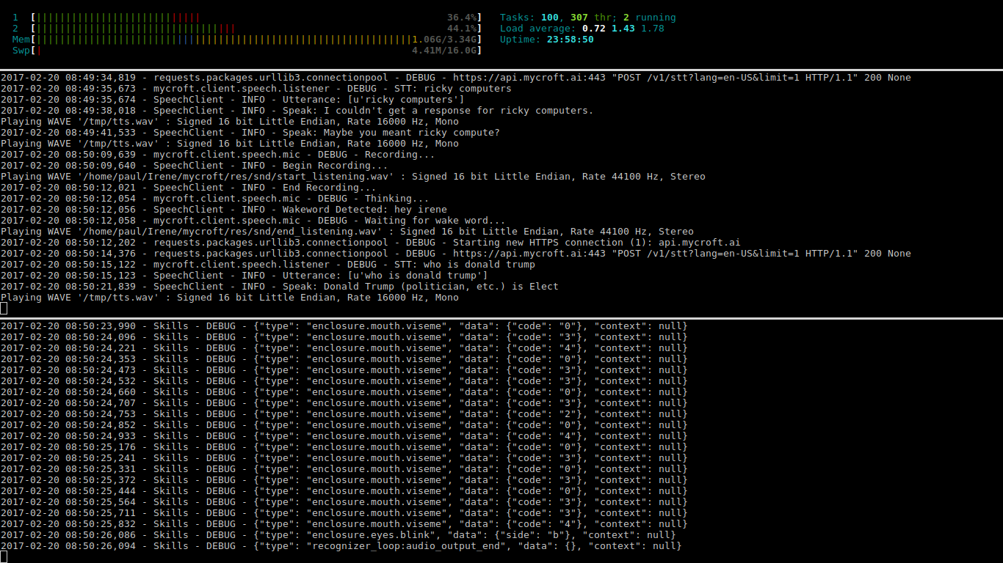

Input: “What time is it?”

Output: “08:47, AM” (Correct Output)

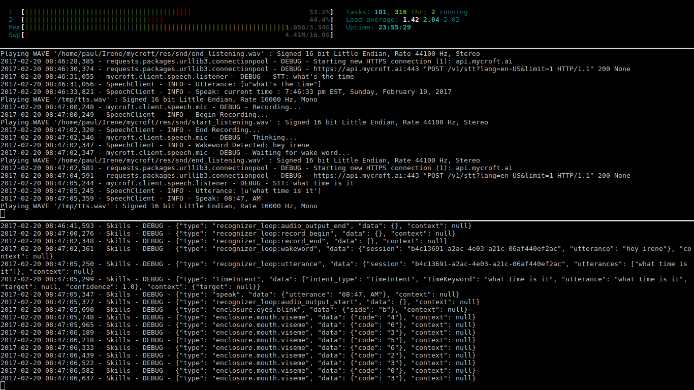

Input: “What’s the time?”

Output: ”Current time: 7:47 PM EST, Sunday, February 19, 2017” (Correct Output)

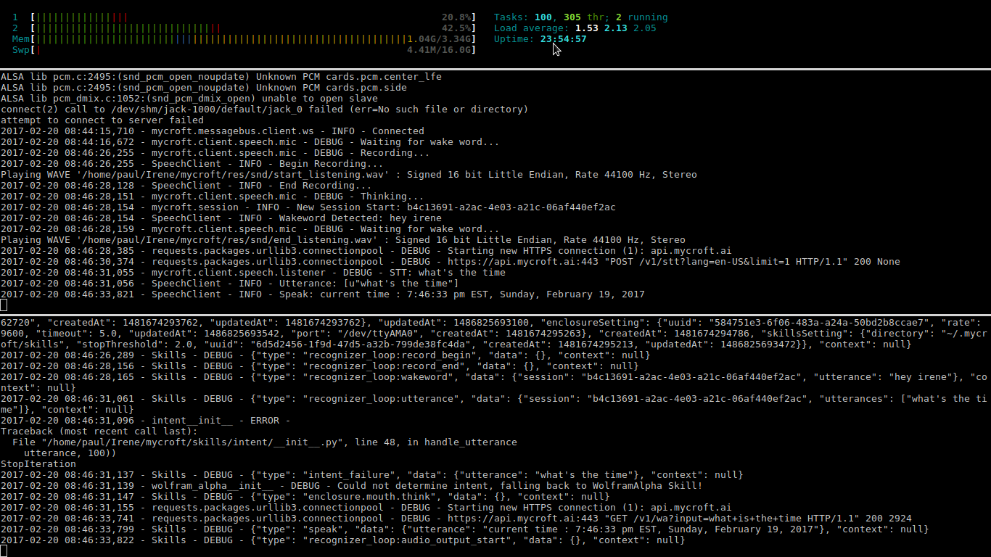

Input: “Tell me about computers.”

Output: “All right, I am looking for computers…” (Correct Output)

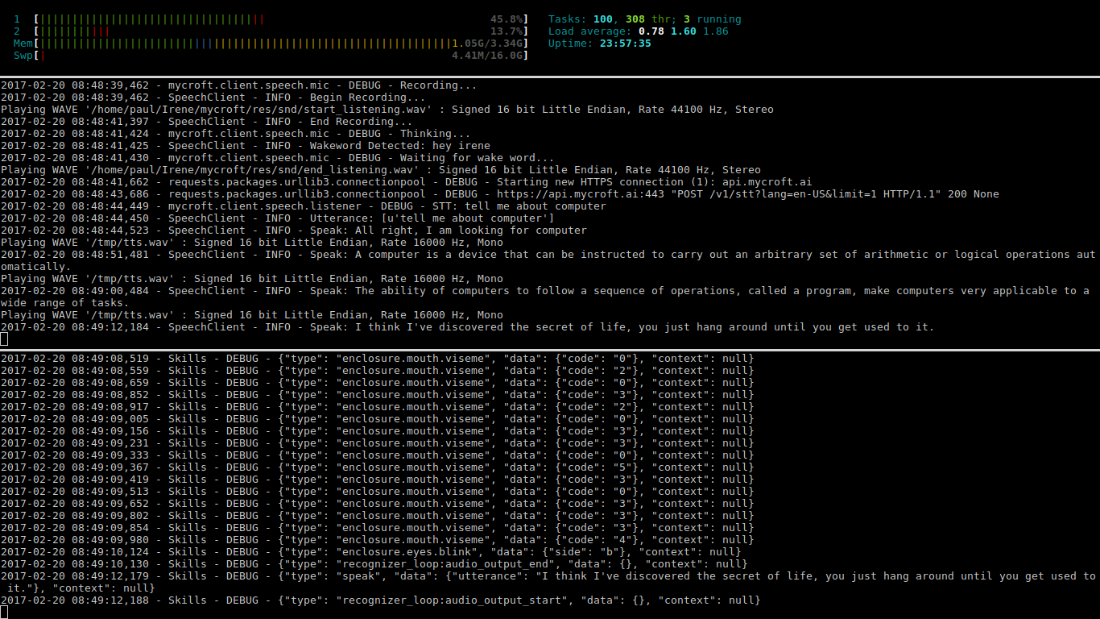

Input: “Wiki about computers.

Output: “Sorry, I couldn’t get a response for ricky computers…” (Wrong Output)

